**ASSIGNMENT NO. 1**

You are required to scrape IMDb website(<https://www.imdb.com>) for a list of 500 unique titles. Please refer to the embedded excel workbook for the same.

*Note that in IMDb, each title has a unique title code. For example, movie Joker has the title code “tt7286456”*



**You need to create an excel workbook with your scrapped data which should look something like this:**

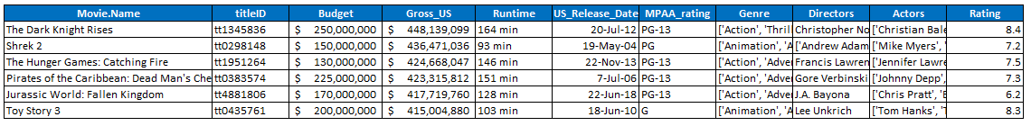

**Fields that you need to scrape from the website are:**

Title Name, Runtime, MPAA Rating, Theatrical Release Date (US), Movie Description, Director(s), Actors, Writers, Genre(s), Language, Budget, Opening Weekend USA, Gross USA & Cumulative Worldwide Gross

**Submission:**

You need to submit the Excel workbook along with your codes in a zipped format.